# Grazioso Salvare Project README (CS-340)

# About the Project/Project Title

Global Rain has been contracted to develop a full-stack application for Grazioso Salvare. This application will include a database to store and manage animal data, and a client-facing web application dashboard for users at Grazioso Salvare to access the database.

The initial phase of this project involves creating a MongoDB database to interact with client-side code, implementing CRUD (Create, Read, Update, Delete) operations for managing animal records, and producing an initial README file. Testing was completed to make sure that each method was working as intended. The subsequent phase involved developing the dashboard with an interactive data table, widgets, and refining the README file to reflect the complete full-stack development.

# Motivation

Grazioso Salvare, an international rescue-animal training company, specializes in identifying and training dogs for search-and-rescue operations, often in life-threatening conditions. These operations include water rescue, mountain or wilderness rescue, locating humans after a disaster, or tracking a specific human's scent.

Grazioso Salvare has partnered with a nonprofit agency that operates five animal shelters in the Austin, Texas region to receive data on available dogs. Grazioso Salvare looks for specific profiles in dogs to determine their suitability for training, such as age (preferably no more than two years old) and breed.

This project will aid in the operations of Grazioso providing an extensive database of animal data and client facing web application dashboard. From this data and filtering they will be able to more quickly identify the best candidates for their specialized dog training.

# Getting Started

1. Ensure MongoDB is installed (refer to installation).
2. Create the database. In this project it was AAC (Austin Animal Control)
3. Create a new user with the correct access (read/write)
4. Import the data from csv file into the database (refer to image below).

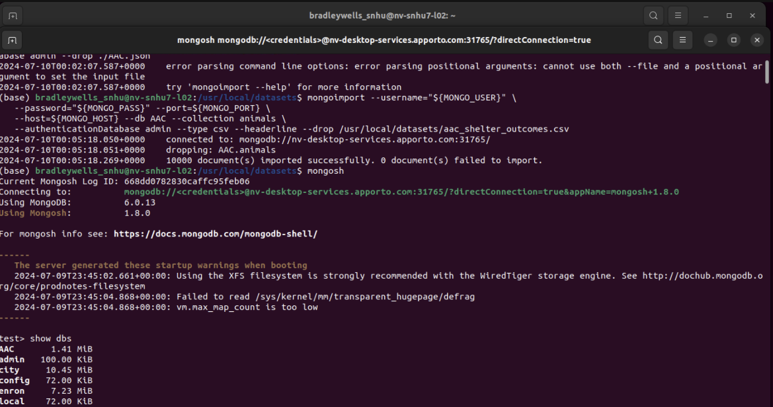

1. Launch the Mongo Shell using command: “mongosh” using the created user account with the correct access. In this case the user “aacuser” was created and given read/write access to the AAC database.

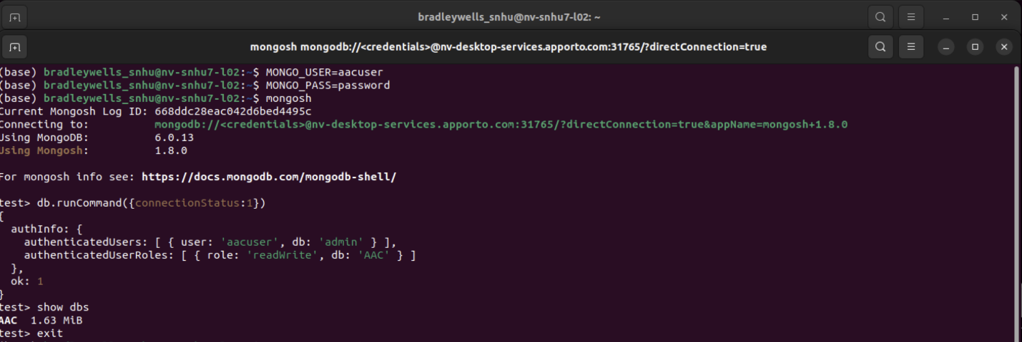

1. You may need to modify the main function in the Grazioso_Salvare.py file to interface correctly with Mongo and the database used. Ensure the following connection variables are correct: USER, PASS, HOST, PORT, DB, COL. These will be dependent on the user that has been created, database, collection, etc.
2. Utilizing Jupyter notebook, with the Grazioso_Salvare.py and Testing_Grazisoso_Salvare.ipynb files in the same directory, the create method can be used to enter the data into the database. If there was data entered, “Create result: Successful” will be seen. (Shown below)

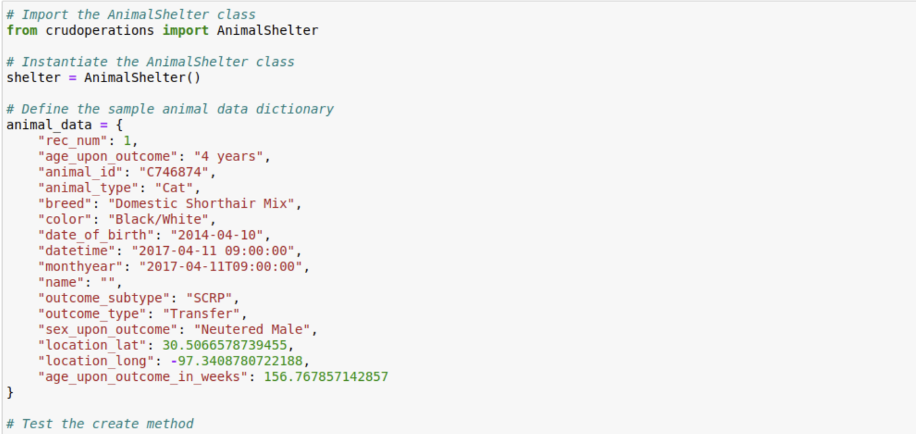

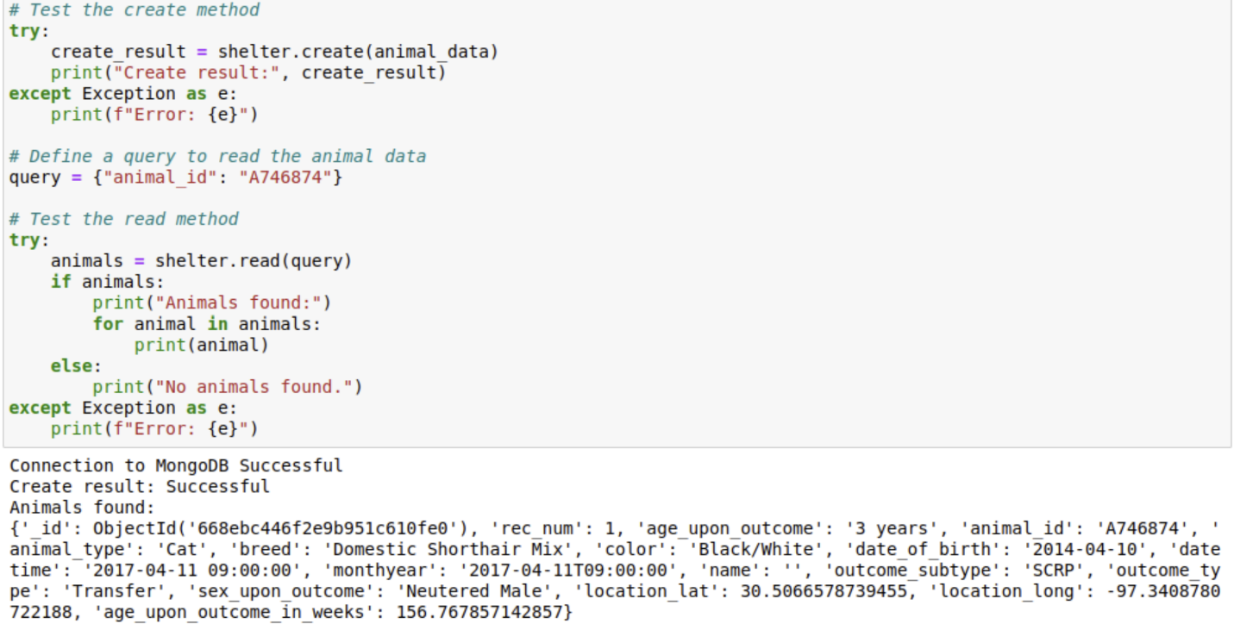

1. The read method can be used to search for data from the database. The search results will be printed. (Shown below)

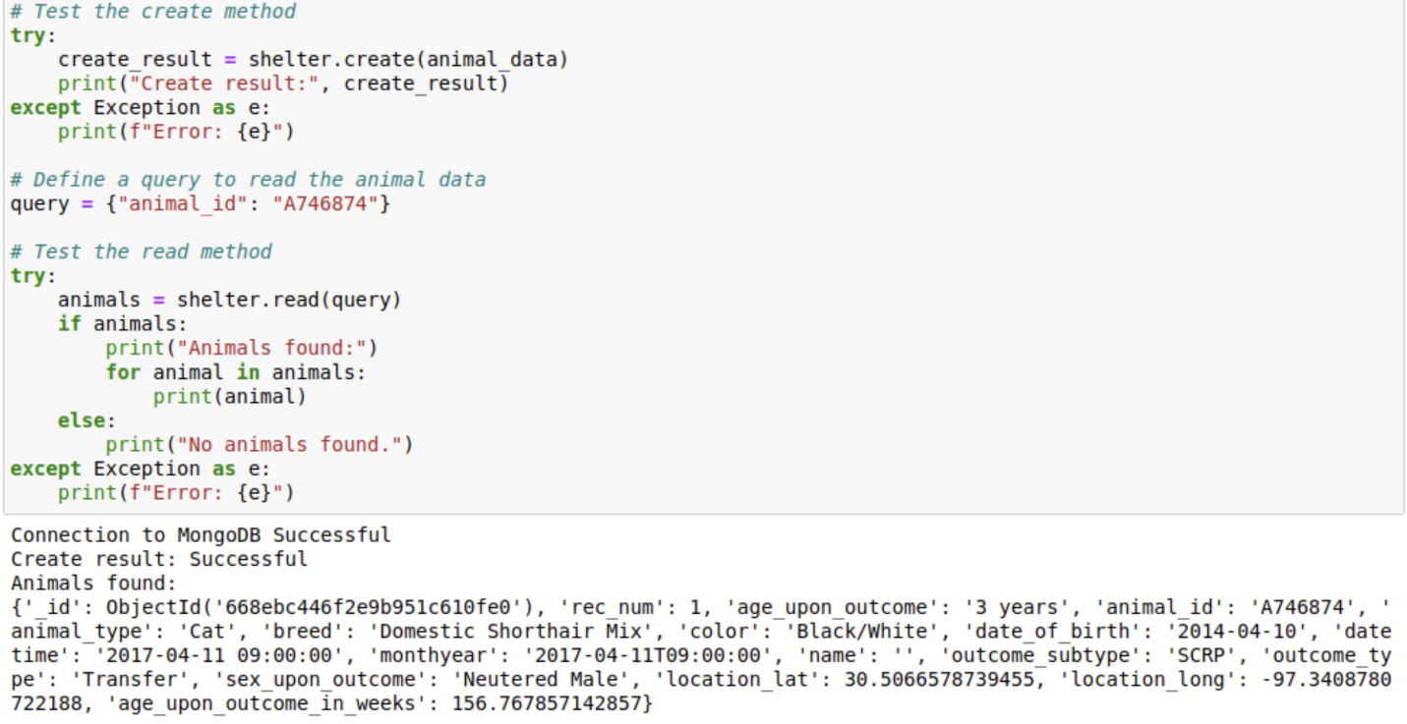

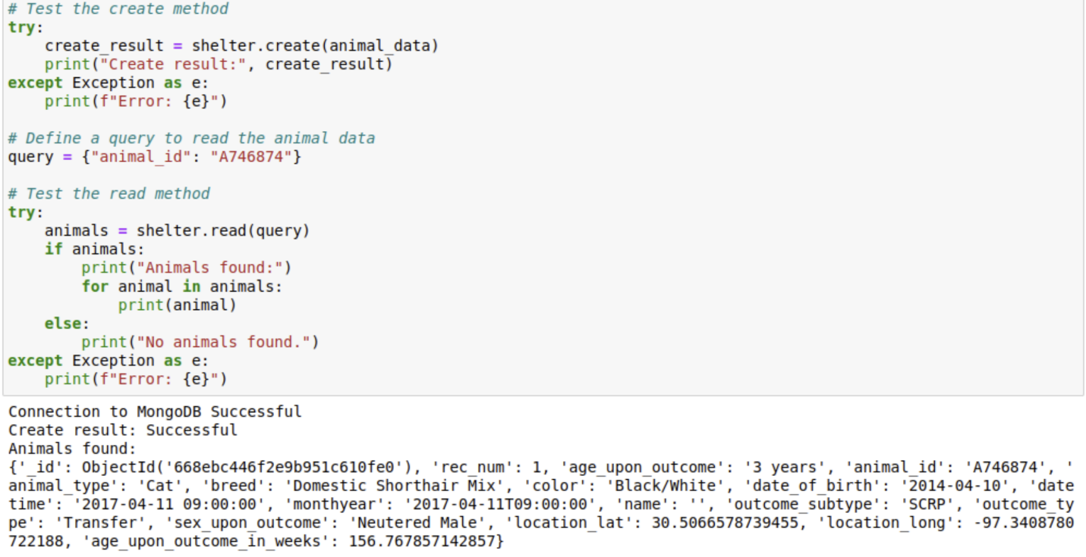

1. The update method can be used to update data in the database, depicted below a name is assigned to an animal id.

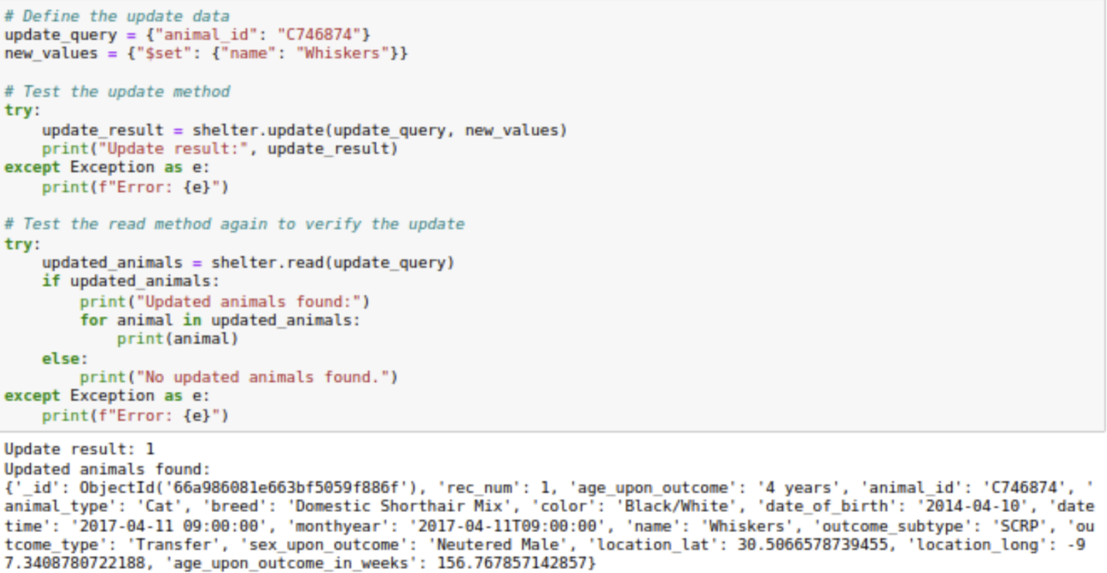

1. Finally, the delete method can be used to delete an entry from the database. Seen below an animal id is selected and deleted from the database with feedback sent to the user on the result of the deletion.

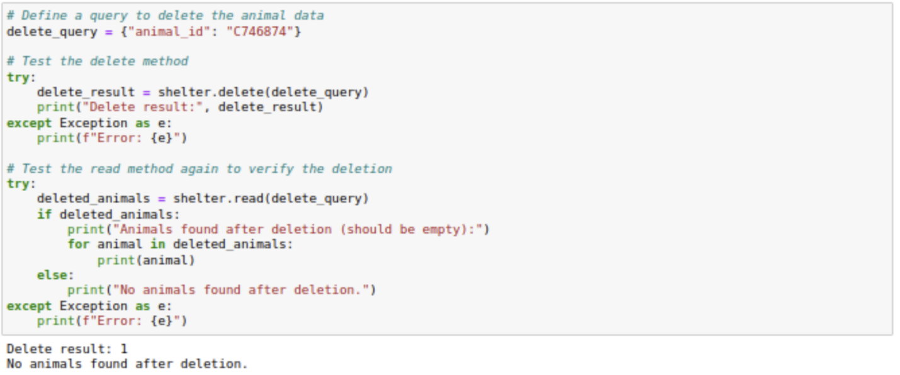

1. Using the Dashboard_Grazisoso_Salvare.ipynb, the dashboard URL can be generated by running the file. The URL opens to the dashboard with the following functionalities: a URL anchored logo, an interactive data table with sort and filter capability, and responsive widgets to include a geolocation map and a pie graph.

# Installation

Tools:

Python- latest version can be downloaded from <https://www.python.org/downloads/>

-preferred for readable syntax and collection of frameworks and libraries like the pymongo for interactions with MongoDB

IDE- Preferred IDE is PyCharm, available from JetBrains at <https://www.jetbrains.com/pycharm/>

MongoDB- <https://www.mongodb.com/try/download/community>

-NoSQL database with flexible design with lots of horizontal scalability that performs well with CRUD operations

Jupyter Notebook- can be hosted online or installed <https://jupyter.org/>

-Ideal environment for testing and debugging code for CRUD operations with the options to

represent data visually all in a single notebook.

pymongo driver- The pymongo driver is a Python library that provides tools to interact with MongoDB databases. This offers an effective way to interact with MongoDB using Python and allows for easy execution of CRUD operations through Python and reflective in the MongoDB. It is also heavily used, which makes support and troubleshooting easy when using the driver.

Dash- downloaded at <https://dash.plotly.com/installation>. Provides interactive web-based data visualization capabilities, allowing the creation of dynamic dashboards that respond to user inputs.

Files:

aac_shelter_outcomes.csv

Grazioso Salvare Logo.png

CS 340 Dashboard Specifications Document.pdf

Grazioso_Salvare.py

Testing_Grazisoso_Salvare.ipynb

Dashboard_Grazisoso_Salvare.ipynb

## Usage

### Code Example

For code examples see the following files attached with this document and located in the GitHub repository: <https://github.com/bcwells24/CS340>

### Grazioso_Salvare.py

Testing_Grazisoso_Salvare.ipynb

Dashboard_Grazisoso_Salvare.ipynb

### Tests

The first test is to ensure there is a good connection with MongoDB and a test for the create method (Screenshots: figure 1). Sample animal data is then input and run with “Create Result: True” to validate successful operation.

Testing the read method (Screenshots: figure 2) queries a portion of the animal data, in this case the animal id. The results are returned and in this case all the animal data that coincides with the queried animal id.

Testing the update method (Screenshots: figure 3) the animal id (C746874) is updated with the name “Whiskers”. This is the animal that was created earlier by the create method. As depicted below, the update takes place, and a read method is used to verify this update.

Deletion is tested (Screenshots: figure 4) by deleting the created animal id (C746874) that was created in testing. One instance of this animal is found in the database and deleted. To verify this has taken place, a read method is used and will notify if there are any animals with the corresponding deletion criteria left in the database, otherwise “No animals found after deletion” will appear.

Testing the Dashboard:

First a connection to MongoDB is confirmed and a URL is provided to get to the dashboard (Screenshots: figure 5).

The main dashboard is presented to the user (Screenshots: figure 6). At the top of the screen Grazioso Salvare’s logo is centered and contains the URL anchor. The title of the dashboard is above the logo. With the creator’s identification underneath the log and to the left of the screen. The unfiltered interactive data table is below this.

Zooming out, below the table (Screenshots: figure 7) a pie graph is bottom left with the breakdown of animal breeds with the interactive map to the left of the pie graph.

Testing the table functionality (Screenshots: figure 8), the table is filtered by “Water Rescue” animals. The table responds to this filter as do the pie graph and the geolocation map, which reacts to the animal that is selected in the table. In this test case, the animal, Catalina is selected, and the map responds appropriately.

The next filter tested is “Mountain Rescue” animals (Screenshots: figure 9. The table responds to this filter as do the pie graph and the geolocation map, which reacts to the animal that is selected in the table. In this test case, the animal, Zeke is selected, and the map responds appropriately.

The following test is the “Disaster Rescue” animal filter (Screenshots: figure 10). The table responds to this filter as do the pie graph and the geolocation map, which reacts to the animal that is selected in the table. In this test case, the animal, Deeohgee is selected, and the map responds appropriately.

Finally, the “Reset” filter is tested (Screenshots: figure 11). The table is reset as it was when the user first accessed the dashboard as do the pie graph and the geolocation map.

### Screenshots

Figure 1

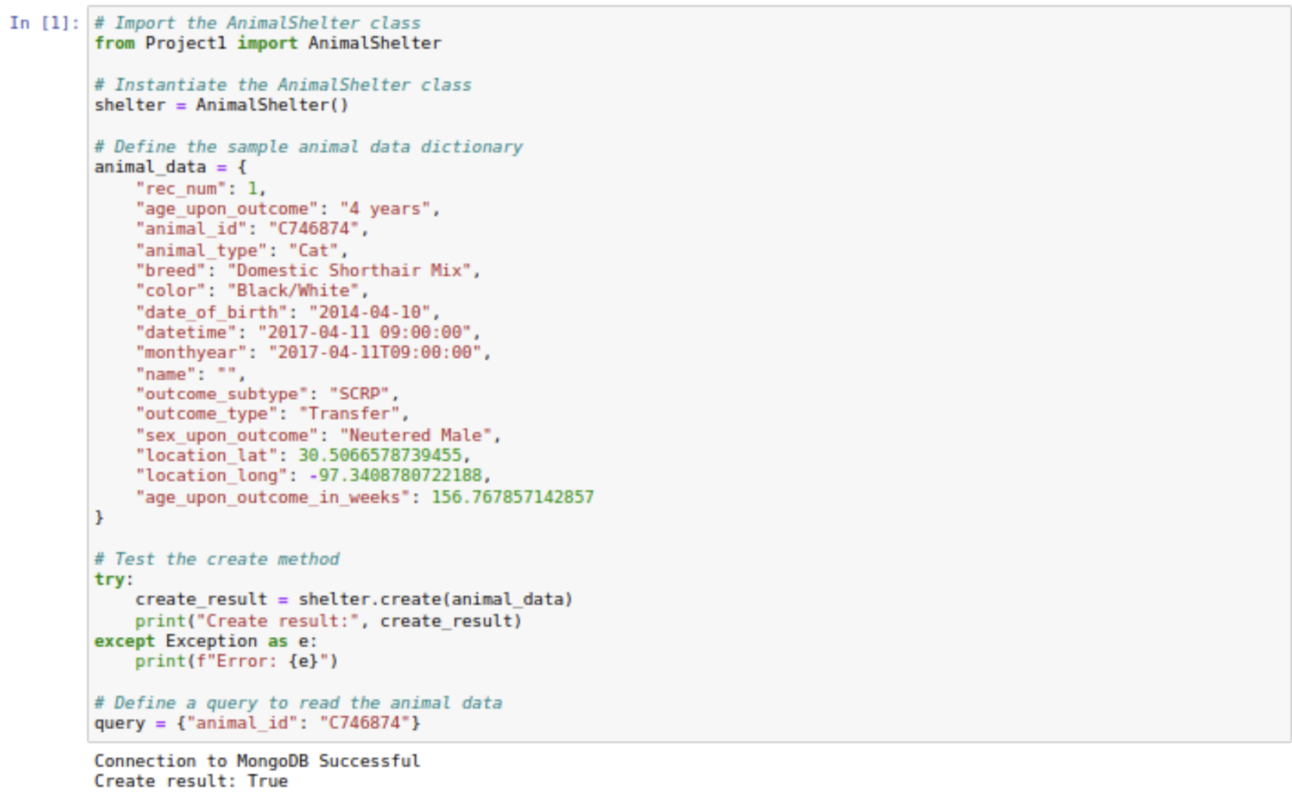

Figure 2

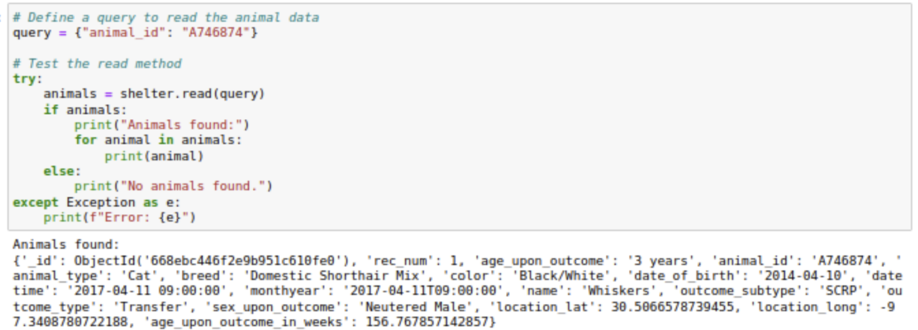

Figure 3

**

Figure 4

**

Figure 5

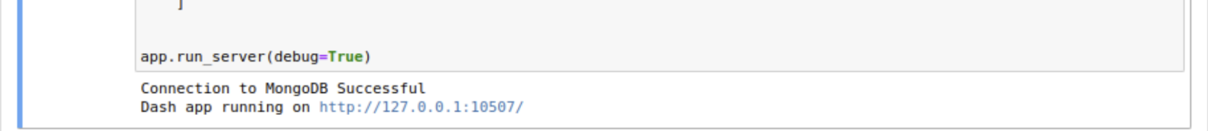

Figure 6

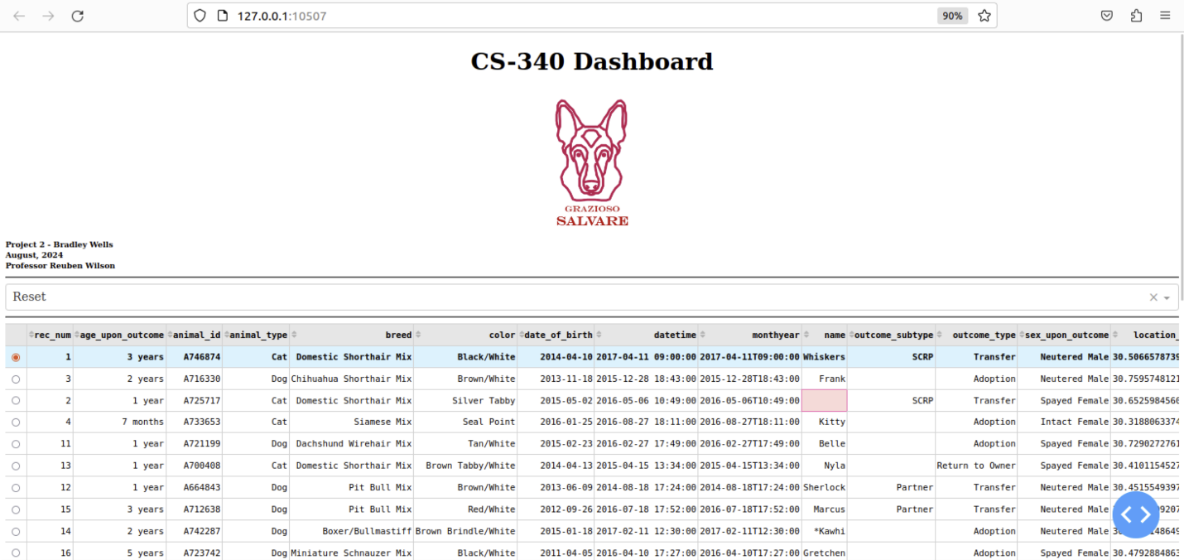

Figure 7

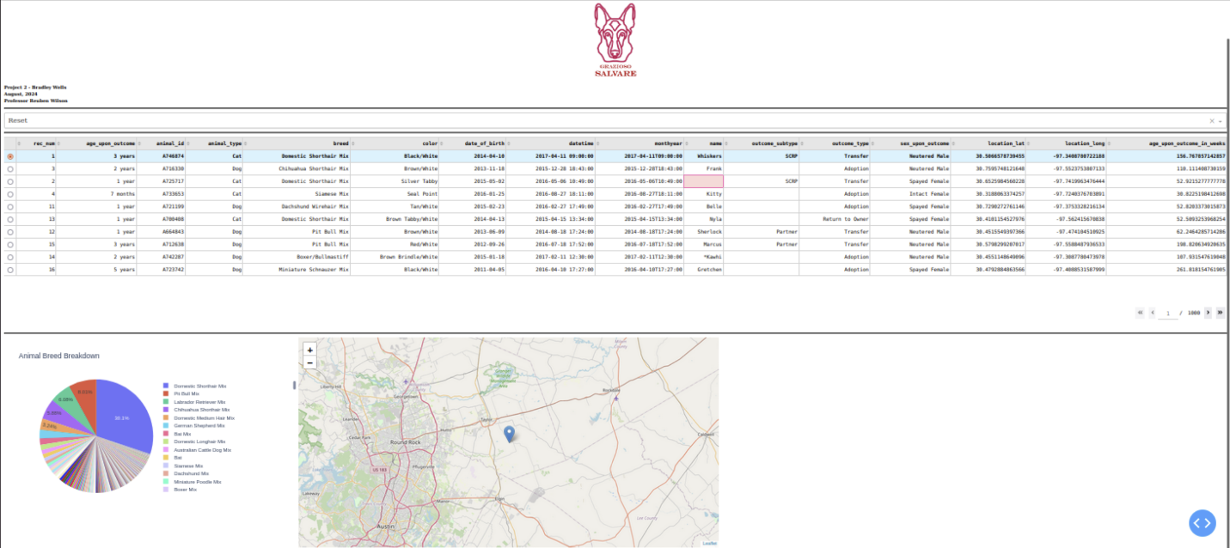

Figure 8

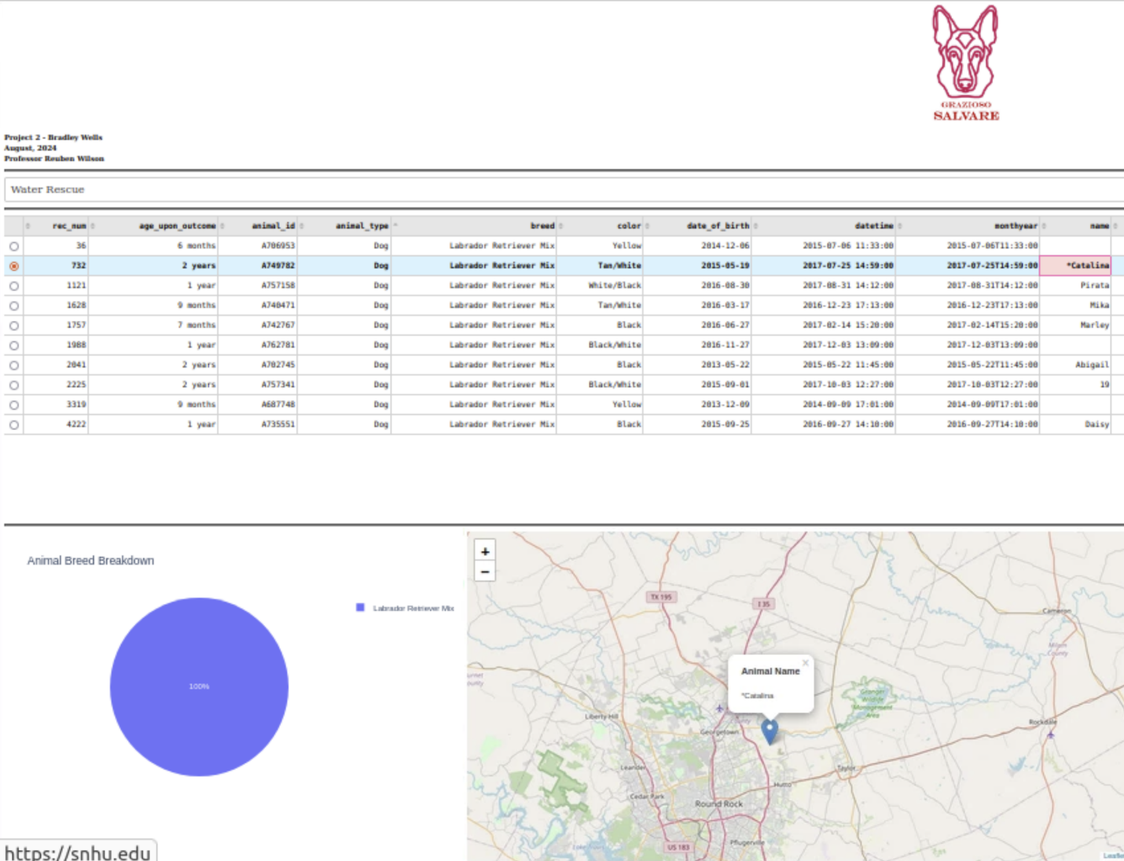

Figure 9

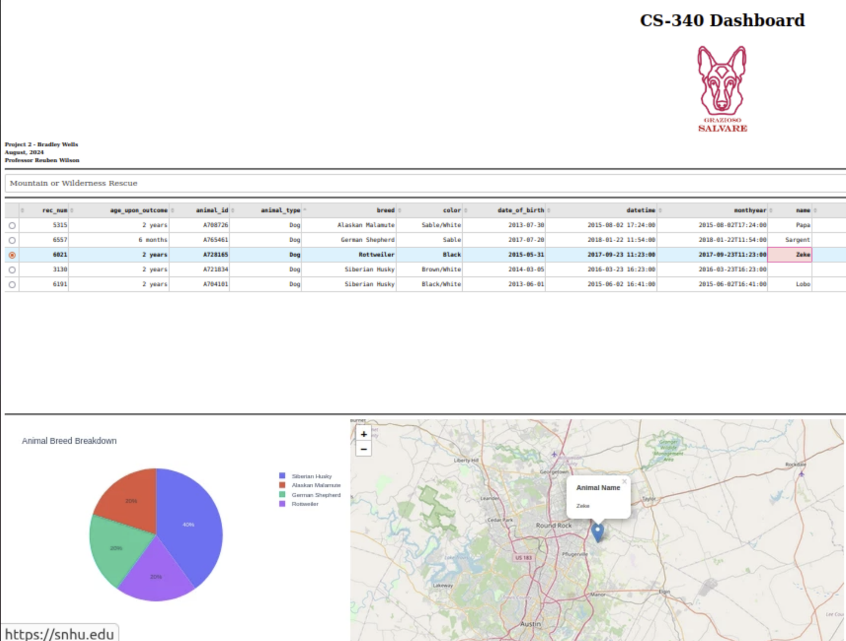

Figure 10

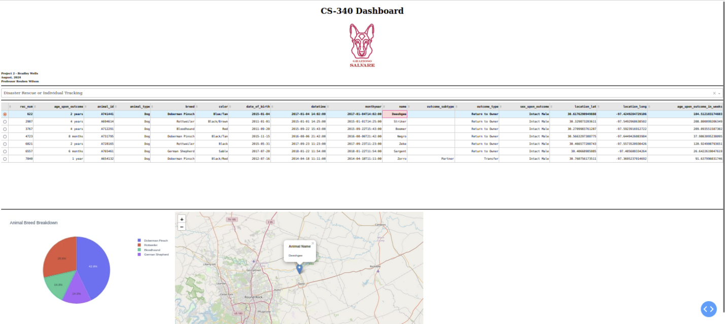

Figure 11

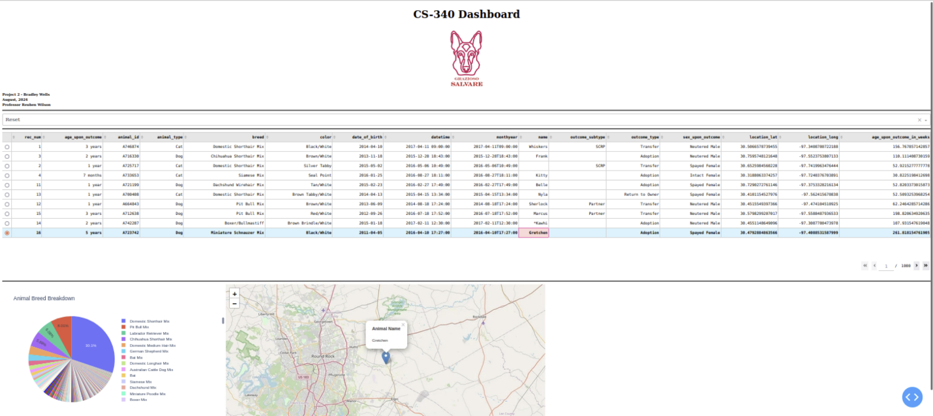

# Summary

Building the dashboard file presented challenges that were addressed through careful and iterative problem-solving. Initially, clarifying the requirements and scope was essential to define the core functionalities like data filtering, table display, and visualization with charts and maps. Integrating data from the AnimalShelter class and ensuring compatibility between libraries such as Dash, Plotly, and Dash Leaflet required managing imports and processing data correctly. Handling user interactions, like filtering and row selection, was managed through Dash callbacks, ensuring dynamic updates to the table, chart, and map. Data handling was necessary to manage MongoDB's ObjectID, which could crash the data table; this was resolved by dropping the '_id' column. Throughout the project, maintaining clear documentation was vital for understanding the code flow and ensuring the dashboard aligned with expectations, achieved through continuous feedback, iterative testing, and code modifications.

## Contact

Name: Bradley Wells

Email: [Bradley.wells@snhu.edu](mailto:Bradley.wells@snhu.edu)